Contents

Nav-bar: 2

Nav-bar usage explained: 2

Nav-bar navigation options: 2

Mobile view and extra information: 2

Home page: 3

Home page usage: 3

Home page images: 3

Objectives section: 5

Objectives section usage: 5

Sign-in page: 5

Sign-in page usage: 5

Security benefits and google integration: 5

Sign-in page images: 6

Items page: 7

Item description: 8

Item description explained: 8

Contact us page: 9

Contact us page explained: 9

Events page: 9

Events page explained: 9

Blog: 11

Blog explained: 11

Opportunities Page 12

Opportunities explained: 12

Mobile responsiveness: 14

Mobile responsiveness explained: 14

Home page: 14

Objectives page: 15

Sign-in page: 19

Items page: 20

Blogs page: 24

Events page: 27

Contact us page: 29

Opportunities Page: 30

# Nav-bar:

## Nav-bar usage explained:

The nav-bar acts as a universal way of navigating between pages and will be consistent between all pages on the refugEAP site. There is a sign in option on the far right of the page where users can sign up to the page or alternatively admins can log in. If an admin chooses to log in using this feature they will unlock admin features, and if a user logs in they will still view the page in its regular format without these privileges.

## Nav-bar navigation options:

They can press a variety of buttons on the nav-bar which will:

* Take them to the home page where they can navigate to other pages or view basic details about the project.
* Take them to the events page where they can view upcoming events or learn more about the project’s objectives.
* Take them to the items page where they can view listed items

## Mobile view and extra information:

Alternatively, they could press the RefugEAP logo in the top left of the nav-bar or the navigate back to the home page.



The nav-bar is also mobile responsive and collapses into the following view unlocking a burger/menu icon on mobile devices:

The mobile view nav-bar consists of a sign in option and a burger/menu icon that expands into the following view:

The user can then choose from the remaining options that were not shown in the collapsed view.

# Home page:

## Home page usage:

The home page consists of some simple information about the page and acts as a portal for users to navigate to and explore other important pages.

## Home page images:

An image of the home page is shown below:

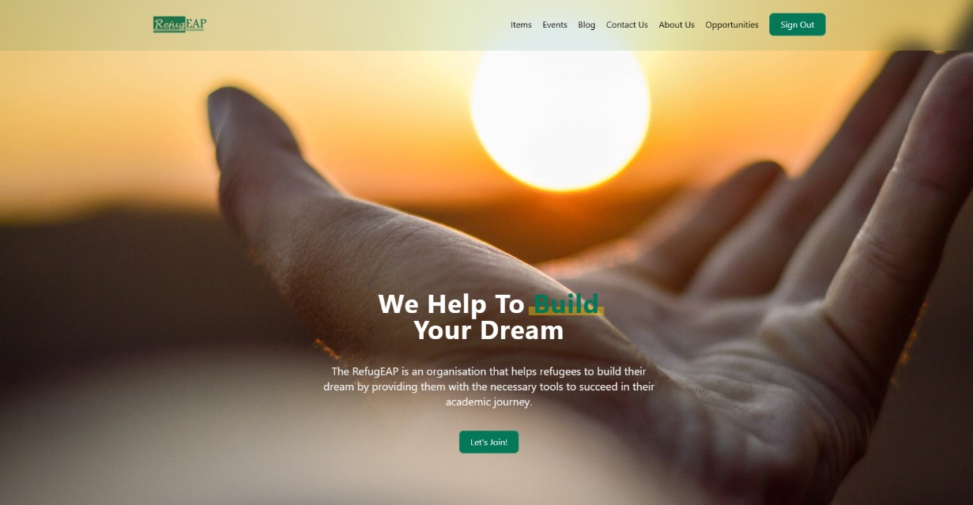

There is one button on the home page – the “Lets join” button. This button scrolls the user to the join us section, lower on the home page.

The home page also has information regarding the programme itself and has a section on how users can volunteer.

The button for more information about the programme redirects the user to this url: <https://le.ac.uk/cite/sanctuary-seekers-unit/initiatives/refugeap>

The expression of interest form redirects the user to this url:

<https://docs.google.com/forms/d/e/1FAIpQLSfy_N8cqvLV2FGPrfWBXR-W64asV0yz4AqdHwDTCiOmH93P7Q/viewform>

There is also a mailing list section which allows users to join our mailing list:

By pressing the button the user is redirected to the existing sign-up form at the following url: <https://www.jiscmail.ac.uk/cgi-bin/webadmin?SUBED1=REFUGEAP-NETWORK&A=1>

# Objectives section:

## Objectives section usage:

The objectives section on the homepage consists of information regarding the 4 core objectives of the refugEAP project. This page is shown below:

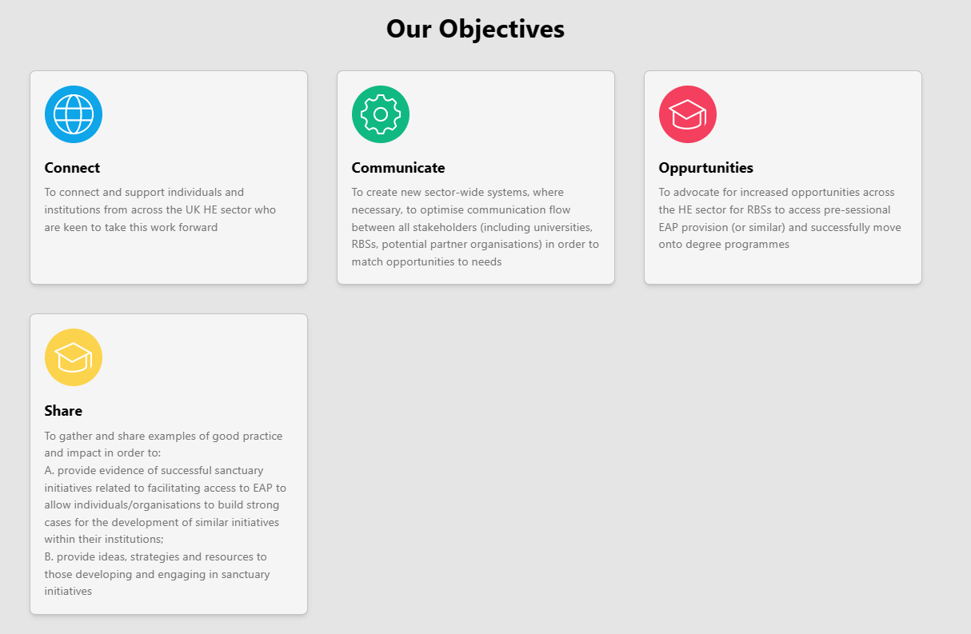

# Sign-in page:

## Sign-in page usage:

The sign-in page has a field for the users to enter their email in their inbox. Once entered the user will be sent a link to the refugEAP page. Once they click this link, they will be returned to the refugEAP page, however this time they will be logged in.

## Security benefits and google integration:

You will notice this login system doesn’t use passwords. This is because our implementation doesn’t require password storage reducing security risks and enabling us to maintain users without worrying about worrying about protecting passwords as none are stored. Alternatively the user could choose to sign in via google which again doesn’t require us to store any passwords. This is a more convenient method of logging in as users will not have to check their inbox.

## Sign-in page images:

An image of the sign-in page is shown below:

If they should choose to sign in via google oAuth2 they will see the following, with their google accounts listed below for them to select from:

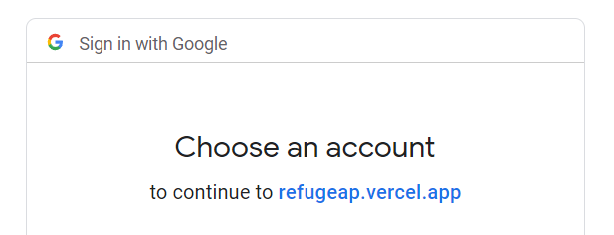

Alternatively, if the user chooses to sign-in via their email:

They will receive the following email:

By pressing the sign-in option they are referred back to the home page and are successfully logged in.

# Items page:

The items page is where refugees can view listed items, and donors can list items for collection. In order to list an item, the user must log in.

Below is an image of the items page:

When the user clicks on an item, they can view more details. Signed-in users can use the “+” icon in the bottom right corner and fill out the following form.

Here the user can enter a title, location, description and also upload images. Once submitted the item will be listed on the page normally.

# Item description:

## Item description explained:

Users can view item descriptions on the items page and see information regarding the item. If it is their own post, they can delete the item as well. They can also zoom in on the image. Admins can select items from the items page and use the delete button to remove the listing if it is inappropriate or unwanted.

Below is an image of this:

# Contact us page:

## Contact us page explained:

Users can view the contact us page where they can view our contact details or fill out a form to ask a question.

An image of this is shown below:

# Events page:

## Events page explained:

The user can view local events and see where they are taking place so they can attend these in person events.

Admins have the ability to remove events as well as comments that are deemed inappropriate. Users can also delete their own posts but not anyone else’s.

Below is an image of the events page:

Admins can also add additional events as shown below by clicking the plus icon:

# Blog:

## Blog explained:

Users can access a blog where they can make posts, or comment on existing posts. Users must be signed in to post/comment however can view posts regardless.

Admins have the ability to remove blog posts as well as comments that are deemed inappropriate. Users can also delete their own posts but not anyone else’s.

Below are images of the blog section:

# Opportunities Page

## Opportunities explained:

The page can be found in the header or footer of the website, clicking the word ‘Opportunities’ will take the user to the page.

On this page, users can find opportunities that may suit there needs. In this instance, the ‘user’ may fall under one of three categories. The first, is a user who is a Refugee Background Student. In this case, they can access the page to find opportunities to kickstart or support their learning. The second is a user who may be a professor, or a user who wants to provide opportunities for Refugee Background Students. If so, they can do so by following the links provided in the opportunities page. The final type of user are general viewing users who access the page out of interest. While they are not viewing the page to look for something, the information is there so they can read and perhaps inform someone who may fall into one of the first two categories.

As well as this, there is also a padlet embedded into the page containing even more links for opportunities, so users who are looking for opportunities can browse the padlet. In addition, any user who knows of an opportunity or a website that can provide support can add to the padlet in the appropriate sub-area with links to websites etc.

Below are images of the opportunities page:

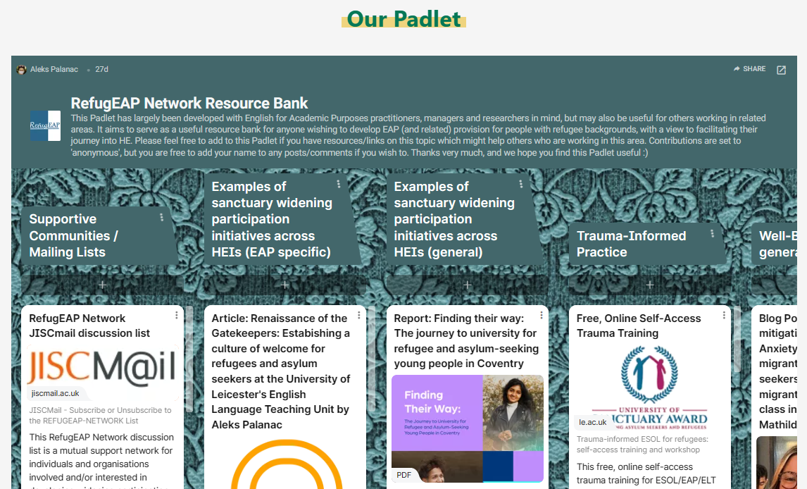

# Mobile responsiveness:

## Mobile responsiveness explained:

Websites must adapt to mobile and desktop screen sizes. A standard desktop site is not accessible on a smaller screen such as a phone or tablet. So all pages we have created are mobile responsive so that they are easily navigable.

Below are screenshots from each page of the website:

## Home page:

## Objectives page:

Note this page can scroll further however I haven’t included the full mobile view:

## Sign-in page:

## Items page:

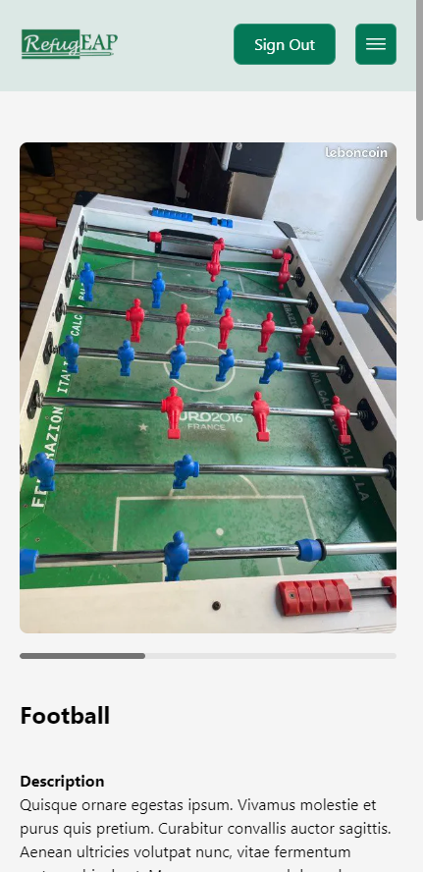

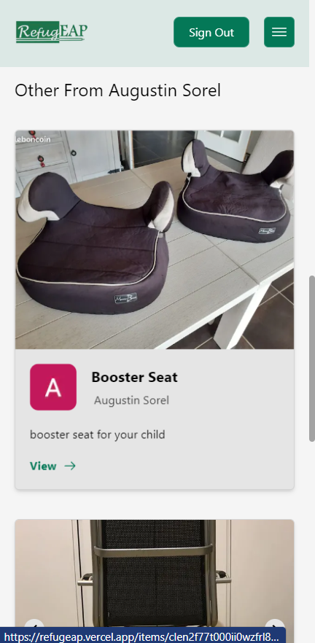

## Blogs page:

## Events page:

## Contact us page:

## Opportunities Page:

Note: If users find it hard to navigate the padlet through the website on mobile, they have the option to open the padlet in a new tab by pressing the arrow in the top-right of the padlet. This should give users more room and make it easier to navigate.